Country (AU, CA, UK) Site Page Template

This template is used for Newsroom, press release Archive, contact, and blog page for all country (AU, CA, UK).

For E.g.

AU Newsroom, AU press release Archive, AU contact, and AU blog page – **AU Site Page**

[**https://www.ancestry.com/corporate/au**](https://www.ancestry.com/corporate/au)

[**https://www.ancestry.com/corporate/au/press-releases**](https://www.ancestry.com/corporate/au/press-releases)

[**https://www.ancestry.com/corporate/au/contact**](https://www.ancestry.com/corporate/au/contact)

CA Newsroom, CA press release Archive, CA contact, and CA blog page – **CA Site Page**

[**https://www.ancestry.com/corporate/ca**](https://www.ancestry.com/corporate/ca)

[**https://www.ancestry.com/corporate/ca/press-releases**](https://www.ancestry.com/corporate/ca/press-releases)

[**https://www.ancestry.com/corporate/ca/contact**](https://www.ancestry.com/corporate/ca/contact)

UK Newsroom, UK press release Archive, UK contact, and UK blog page – **UK Site Page**

[**https://www.ancestry.com/corporate/uk**](https://www.ancestry.com/corporate/uk)

[**https://www.ancestry.com/corporate/uk/press-releases**](https://www.ancestry.com/corporate/uk/press-releases)

[**https://www.ancestry.com/corporate/uk/contact**](https://www.ancestry.com/corporate/uk/contact)

Basic Tab

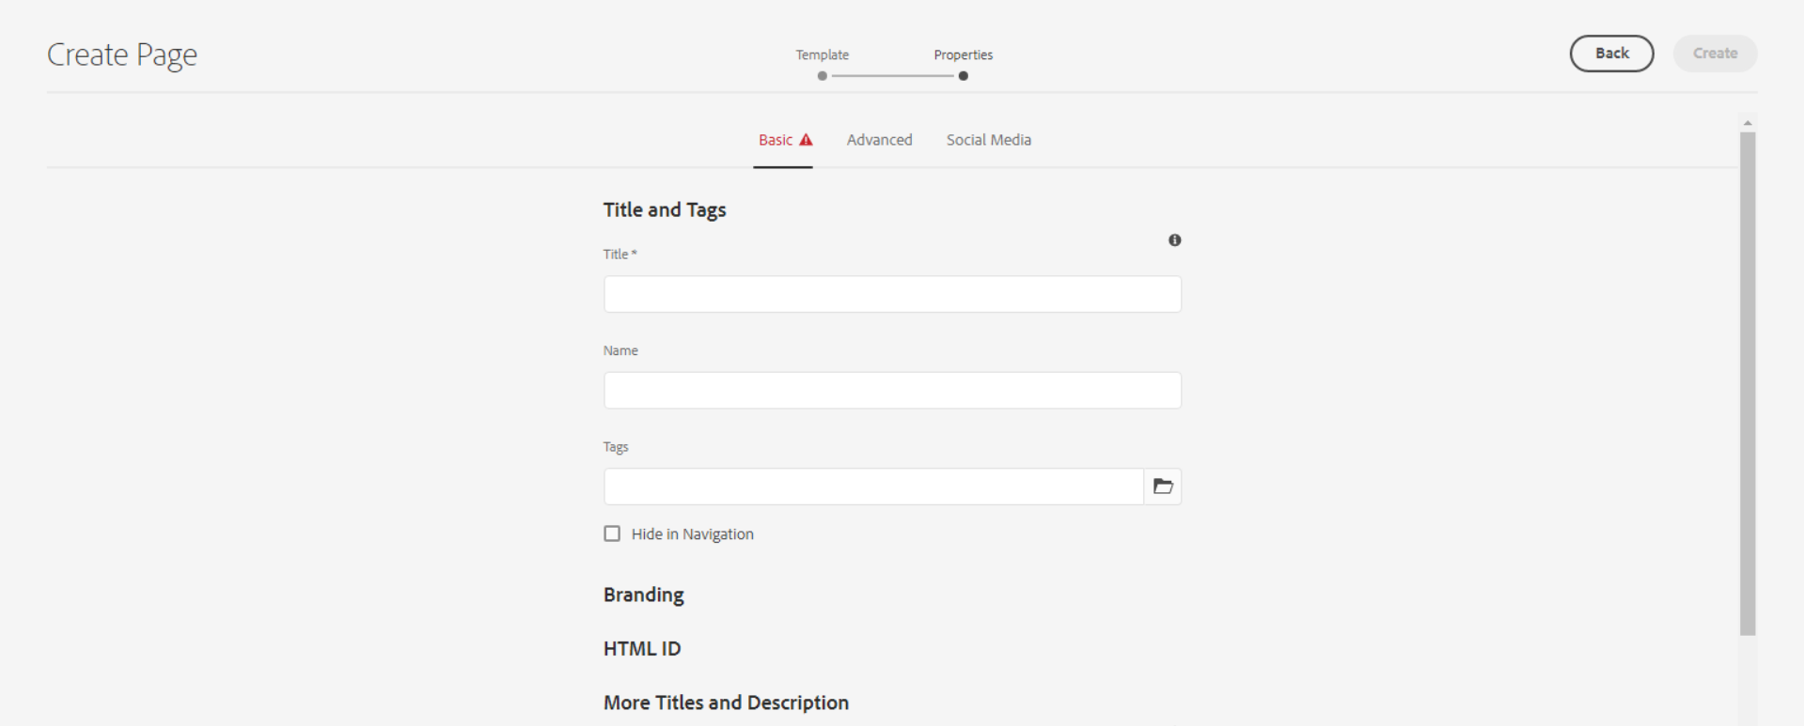

**Title** – Defines the page meta title for SEO, as well as a title displayable in the page content (unless an overriding 'Page Title' is defined).

**Name** – It should be the page name.

**Tags** – Defines the page meta tag for SEO

**Checkbox for Hide in Navigation** – This is for hide the page from header navigation.



**Page Title** - Defines a page title that is displayable in the page content, instead of the 'Title'.

**Navigation Title** - Defines a navigation title that is displayed in site navigation menus, instead of the 'Page Title' or 'Title'.

Advanced Tab

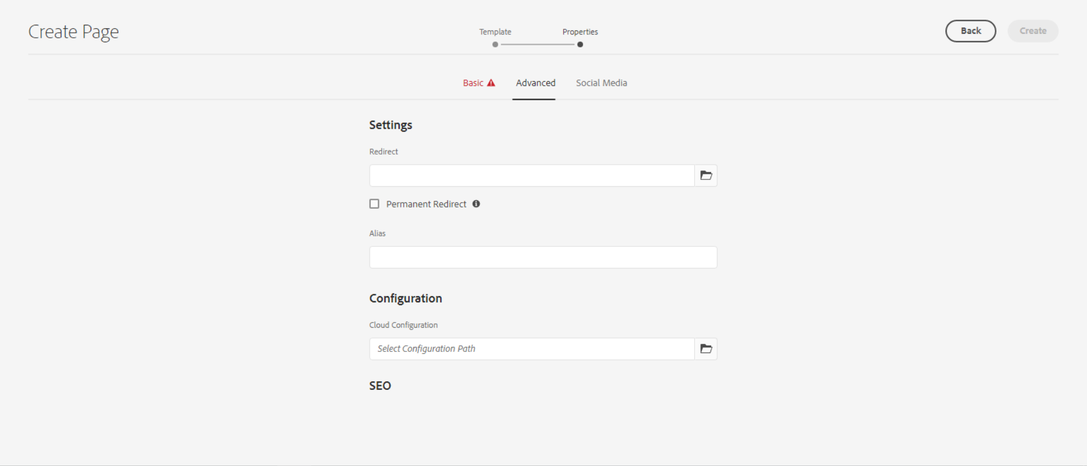

**Redirect** – Here we can set the internal or external redirect path

**Checkbox for Permanent Redirect** – can be checked to enable Permanent Redirect.

Social Media Tab

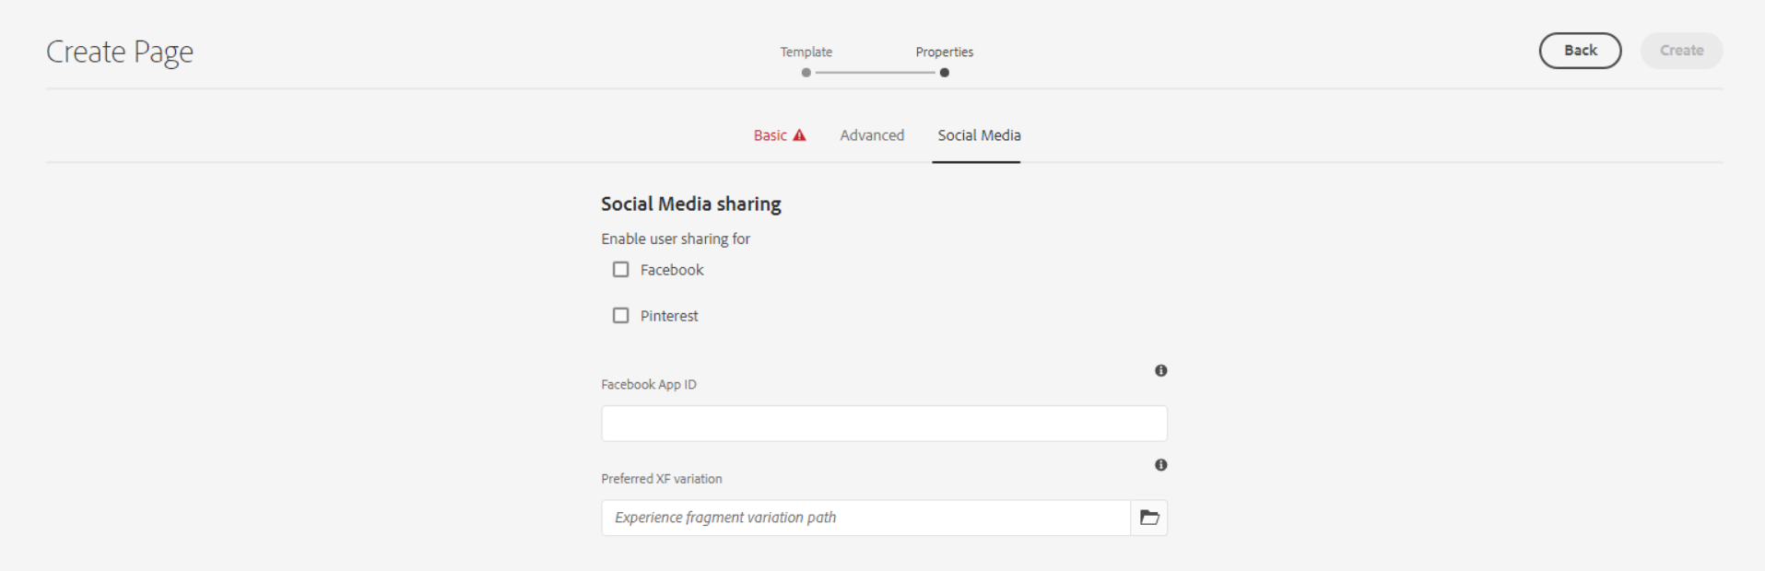

This is for social media Sharing.

Thumbnail Tab

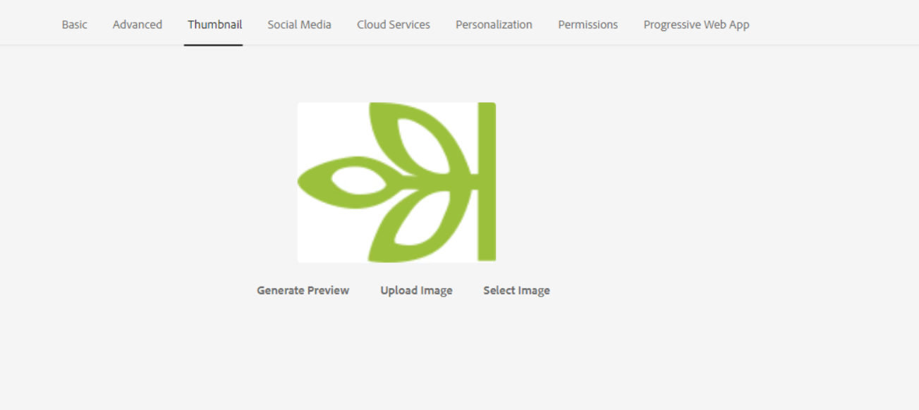

Here we can add or upload thumbnail image of the page.

AU Newsroom, AU press release Archive, AU contact, and AU blog page – **Author AU Site Page**

[**http://localhost:4502/content/ancestry-corp/en-us/global-newsrooms/au/newsroom.html?wcmmode=disabled**](http://localhost:4502/content/ancestry-corp/en-us/global-newsrooms/au/newsroom.html?wcmmode=disabled)

[**http://localhost:4502/content/ancestry-corp/en-us/global-newsrooms/au/press-releases.html?wcmmode=disabled**](http://localhost:4502/content/ancestry-corp/en-us/global-newsrooms/au/press-releases.html?wcmmode=disabled)

[**http://localhost:4502/content/ancestry-corp/en-us/global-newsrooms/au/contact.html?wcmmode=disabled**](http://localhost:4502/content/ancestry-corp/en-us/global-newsrooms/au/contact.html?wcmmode=disabled)

CA Newsroom, CA press release Archive, CA contact, and CA blog page – **Author CA Site Page**

**http://localhost:4502/content/ancestry-corp/en-us/global-newsrooms/**[**ca**](http://localhost:4502/content/ancestry-corp/en-us/global-newsrooms/ca/press-releases.html?wcmmode=disabled)**/newsroom.html?wcmmode=disabled**

[**http://localhost:4502/content/ancestry-corp/en-us/global-newsrooms/ca/press-releases.html?wcmmode=disabled**](http://localhost:4502/content/ancestry-corp/en-us/global-newsrooms/ca/press-releases.html?wcmmode=disabled)

**http://localhost:4502/content/ancestry-corp/en-us/global-newsrooms/**[**ca**](http://localhost:4502/content/ancestry-corp/en-us/global-newsrooms/ca/press-releases.html?wcmmode=disabled)**/contact.html?wcmmode=disabled**

UK Newsroom, UK press release Archive, UK contact, and UK blog page – **Author UK Site Page**

**http://localhost:4502/content/ancestry-corp/en-us/global-newsrooms/uk/newsroom.html?wcmmode=disabled**

[**http://localhost:4502/content/ancestry-corp/en-us/global-newsrooms/uk/press-releases.html?wcmmode=disabled**](http://localhost:4502/content/ancestry-corp/en-us/global-newsrooms/ca/press-releases.html?wcmmode=disabled)

**http://localhost:4502/content/ancestry-corp/en-us/global-newsrooms/uk/contact.html?wcmmode=disabled**